Online exam system Problem Statement:
Schools, colleges, and universities are finding it difficult to conduct fair and reliable online exams. Many existing tools do not properly verify who is taking the exam, and they fail to prevent cheating. Students often face issues like slow internet, sudden connection drops, or their answers not being saved, which creates stress and affects their performance.
On the other side, teachers struggle to manage large sets of questions, create exam schedules, monitor students effectively, and grade answers on time. There is no simple way for them to track performance or understand which questions were too easy or too difficult.
Because of these challenges, institutions need a single, secure system that can handle everything from identity verification and question management to proctoring, grading, and result publishing. This project aims to solve these problems by creating an easy-to-use and trustworthy online examination platform that works smoothly for students, teachers, and administrators.

User story:
The client wants an online examination system that allows students to take exams securely from any location. He needs the system to provide secure login, identity verification, and strict exam control so that students cannot cheat or misuse the platform. The client expects features like question randomization, autosaving of answers, timer enforcement, and smooth exam resumption if the network disconnects.
He also wants examiners to easily create exams, manage a question bank, schedule exam times, and monitor students through AI or human proctoring. After the exam, the system should support automatic grading for objective questions and manual grading for written answers, along with clear result publishing and performance reports.
Overall, the client needs a reliable, user-friendly examination solution that ensures fairness, security, and efficient management of the entire exam process.

Functional Requirements (FR):

FR-01: User Authentication & Access Control
The system must allow users (students, examiners, and administrators) to securely log in using username/password or two-factor authentication. Each user must only access features permitted by their assigned role.

FR-02: Identity Verification Before Examination
Before starting the exam, the system must verify the student’s identity using photo capture, government ID upload, or AI-based facial recognition.

FR-03: Exam Scheduling & Availability
Examiners must be able to create exams by setting the date, time, duration, and access rules. Students should only be able to enter the exam during the predefined active exam window.

FR-04: Question Bank & Randomization
The system must allow examiners to create, edit, categorize, and store questions. It must also generate randomized question sets for each student to reduce cheating.

FR-05: Secure Browser Lockdown Mode
During the examination, if lockdown mode is enabled, the system must disable new tabs, screen capture tools, copying/pasting, and switching between applications.

FR-06: Automated Proctoring (AI Monitoring)

The system must monitor students through webcam and microphone to detect suspicious activities, such as:

FR-07: Live Human Proctoring Option
The system must allow human proctors to monitor students in real-time with features including:

FR-08: Autosave of Answers
The system must automatically save the student’s answers every few seconds to prevent loss of responses due to device or network issues.

FR-09: Resume Exam After Network Failure
If the student loses internet connection, the exam must pause or continue based on institutional policy. When the student reconnects, they must be able to resume without losing previously saved answers.

FR-10: Timed Examinations & Time Enforcement
The system must display a countdown timer for each exam and automatically submit answers when the timer expires.

FR-11: Automatic Grading for Objective Questions
The system must automatically grade multiple-choice, true/false, and other objective question types and record the results instantly.

FR-12: Manual Grading for Descriptive Questions
The system must provide an interface for instructors to manually grade essay or descriptive answers, including rubrics, comment sections, and scoring tools.

FR-13: Result Publishing & Feedback
After grading is complete, the system must publish results for students, including score breakdowns, examiner feedback, and analytics (if available).

FR-14: Reporting & Analytics Dashboard
The system must generate analytical reports for administrators and examiners, such as:

Non-Functional Requirements (NFR) :

NFR-01: Security

NFR-02: Performance & Scalability

NFR-03: Availability & Reliability

NFR-04: Usability & Accessibility

NFR-05: Data Integrity & Backup
.
NFR-06: Privacy & Compliance
.

Project Scope:
1. User Access & Security
- The system will provide secure accounts for students, examiners, and admins.
- Role-based access will ensure each user only sees features meant for them.
- Identity verification (photo/ID/AI check) will confirm that the right student is taking the exam.
2. Exam Creation & Management
- Examiners will be able to create exams, set dates, times, and durations.
- A question bank will store all questions, which can be added, edited, or categorized.
- The system will generate randomized question sets to prevent cheating.
3. Exam Environment for Students
- Students can join the exam only within the scheduled time window.
- A countdown timer will guide students throughout the exam.
- The exam interface will automatically save answers to avoid data loss.
- If the internet disconnects, the system will pause or continue the exam based on policy and allow the student to resume.
4. Monitoring & Proctoring
- AI proctoring will detect suspicious behavior such as multiple faces, phone usage, or noise.
- Human proctors will have a dashboard to watch students live and take actions like warning, pausing, or ending the exam.
5. Evaluation & Results
- Objective questions will be graded automatically.
- Descriptive answers will be graded manually using an examiner-friendly interface.
- Results will be published with detailed feedback and score breakdowns.
6. Reporting & Analytics
- The system will generate performance reports for students, examiners, and admins.
- Analytics will include question difficulty, student performance trends, and comparison charts.
7. System Reliability & Support
- The platform will ensure high security, data backup, and system reliability.

USE CASES:

UC-01: Login & Authentication
UC-02: Verify Student Identity
UC-03: Schedule Examination
UC-04: Manage Question Bank
UC-05: Generate Random Questions
UC-06: Start Examination
UC-07: Submit Timed Examination
UC-08: Proctoring (AI/Human)
UC-09: Resume Examination

USE CASE DIAGRAM:

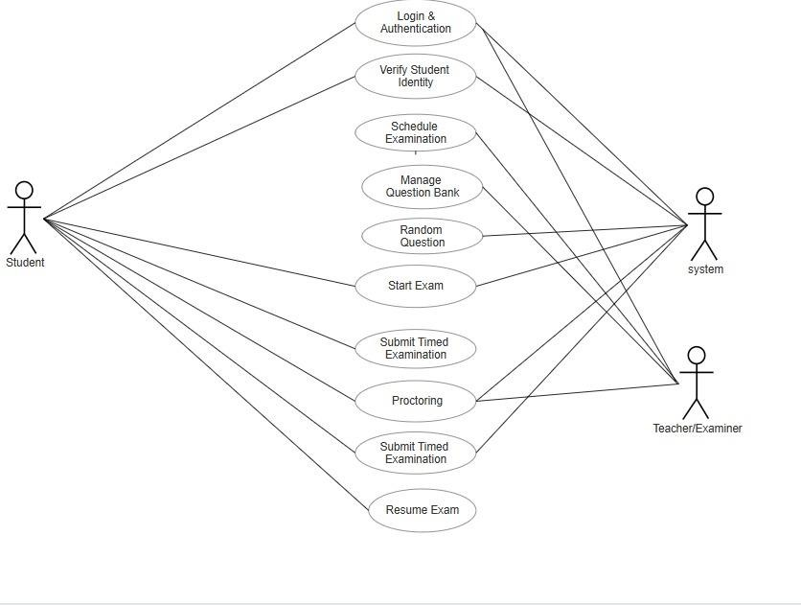

TIMELINE:
Week | Feature / Functional Requirement | Description
Week 1 | FR-01: User Authentication & Access Control | Login system, password protection, 2FA, user roles & permissions.
Week 1–2 | FR-02: Identity Verification Before  Exam | ID upload, live camera check, AI-based facial matching.
Week 2 | FR-03: Exam Scheduling &  Availability | Create exam, set date/time, manage availability window.
Week 2–3 | FR-04: Question Bank & Randomization | Add questions, categorize, auto-generate randomized question papers.
Week 3 | FR-05: Secure Browser Lockdown Mode | Disable copy-paste, block new tabs, prevent window switching.
Week 3–4 | FR-06: Automated Proctoring (AI Monitoring) | Detect cheating: multiple faces, phone usage, suspicious audio/noise.
Week 4 | FR-07: Live Human Proctoring | Real-time monitoring dashboard, send warnings, pause/terminate session.
Week 4–5 | FR-08: Autosave of Answers | Auto-save responses every few seconds to avoid data loss.
Week 5 | FR-09: Resume Exam After Network Failure | Offline answer caching, restore exam session after reconnection.
Week 5–6 | FR-10: Timed Examinations & Enforcement | Countdown timer, auto-submit when time expires.
Week 6 | FR-11: Automatic Grading (MCQ) | Instant MCQ scoring using predefined logic/rules.
Week 6–7 | FR-12: Manual Grading (Essay/Descriptive) | Interface for evaluators: rubric scoring, comments, marking tools.
Week 7 | FR-13: Result Publishing & Feedback | Publish scores, provide breakdown, share feedback.
Week 7–8 | FR-14: Reporting & Analytics Dashboard | Student performance charts, question-wise analysis, downloadable reports.

